# Minecraft Forest

Introduction

In this project you will create a forest in Minecraft using Python, You will use functions to write code that you can use over and over again.

Step 1: Connect Python to Minecraft

Open Minecraft and create a new world

Open Python 3 Shell

File – New File

Type the code that connects Minecraft and Python

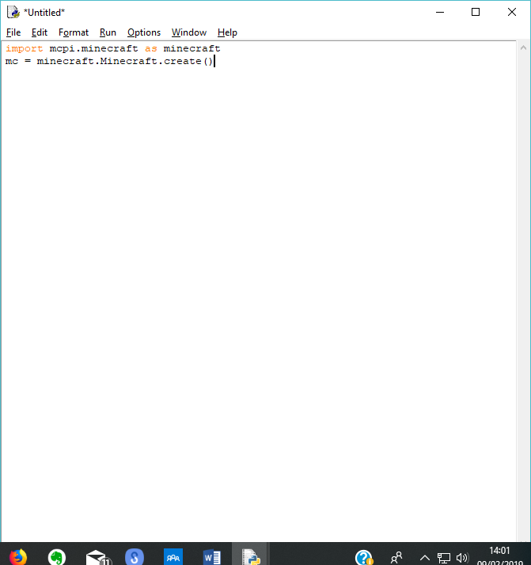

Step 2: Create a function to make one Tree

Define the materials you need

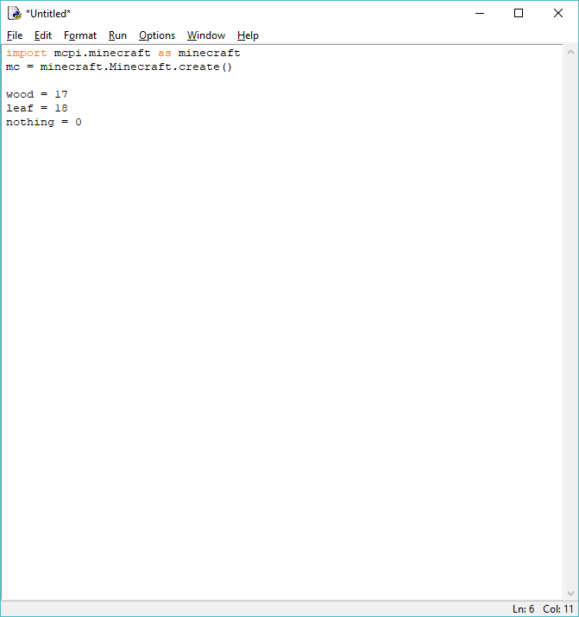

Build the tree

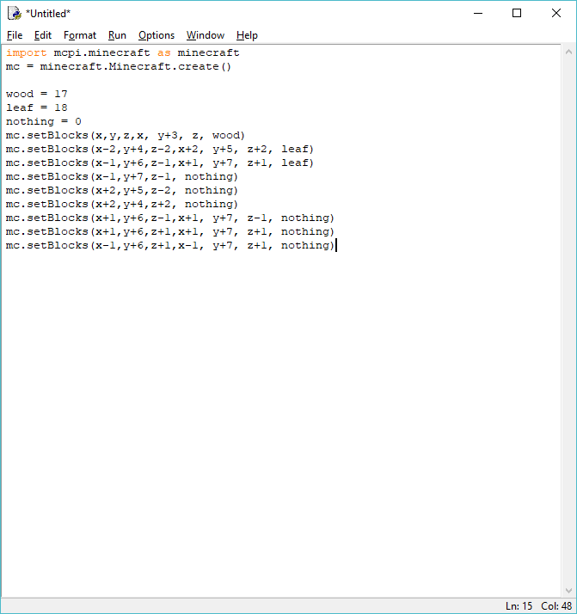

Step 3: Position the Tree in Minecraft

Add the position code before the building of the tree

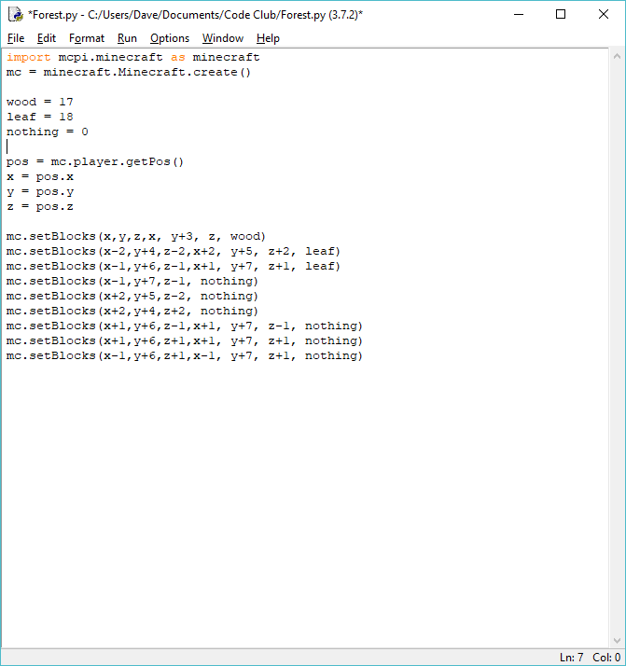

Step 4: Check you have built a tree

Run – Run Module

Save source code

Back to Minecraft and check if there is a tree

Step 5: Make several trees

Create a function. For any function it will always : at the end of the line. Make sure all the code for the tree has got a tab before it as an indent will show that it is part of that function.

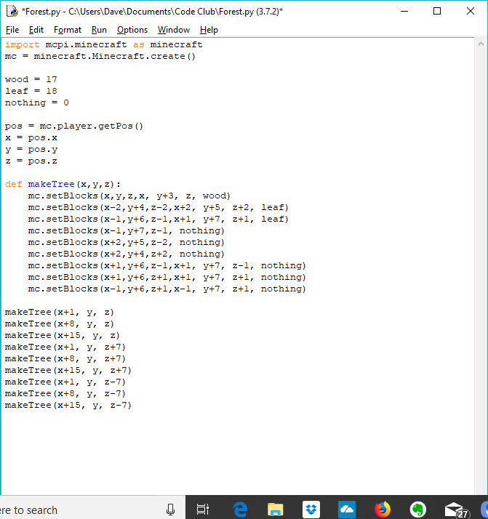

Call the function

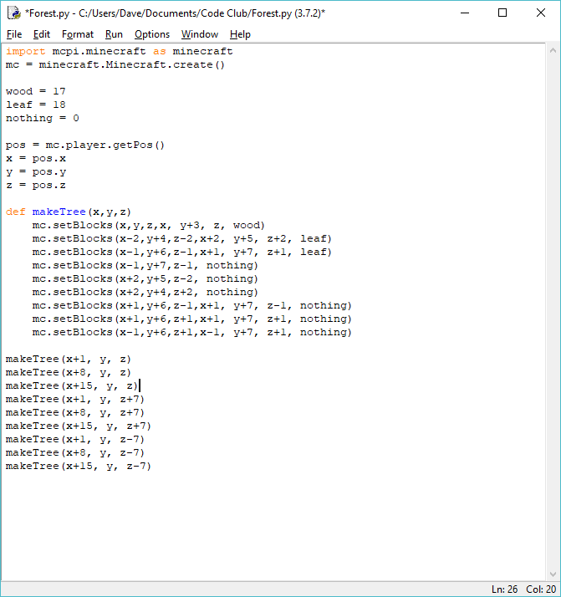

Now run the code to see what you have built

Step 6: Challanges

Now try to do these:

Use different materials

Use the random function to create them in different positions

Build a forest as you walk